A Quick Look at Equivalence Relations and Quotient Spaces .
Berkeley Math Circle January 7, 2014
Instructor: Roseanna Pealatere

1. a. {{0,2,4,6,8}, {1,3,5,7,9}}
b. {{0,3,6,9}, {1,4,7}, {2,5,8}}
c. {{1,2,3,5,8}, {0,4,6,7,9}}
d. {{2,3,5,7}, {0,1,4,6,8,9}}
e. {{celery, lettuce, cucumber}, {tomato, strawberry}, {blueberry}}
f. {{Sacramento, Los Angeles}, {New York City}}
g. {{cat, mouse, bear}, {lizard, snake}, {frog, salamander}}

2. a. {0,1,2,3,4,5,6,7,8,9}
b. {celery, lettuce, cucumber, tomato, strawberry, blueberry}
c. {cat, mouse, bear, lizard, snake, frog, salamander}
d. {equilateral triangle, regular hexagon, circle, ellipse, scalene triangle}
e. the set of all points in the plane, based on distance from the origin
f. the set of all students in this classroom, based on number of rows/columns/sum of both away from the front left corner

3. a. b. c.

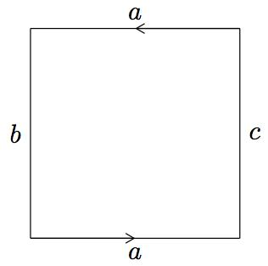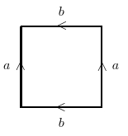
d. What about the plane under an equivalence relation identifying all points on the unit circle together?

e. f. g.
